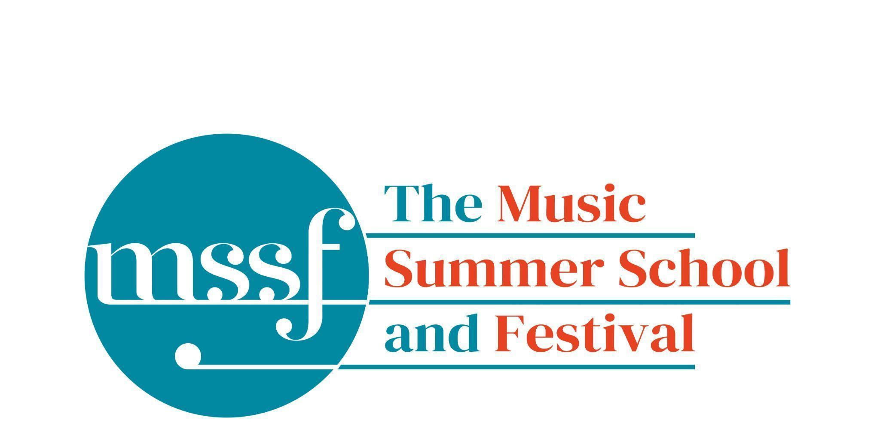

Daily Programme
Tuesday 5 August 2025

Tai-Chi - Moving Meditation  With Doris Schierer | Chapel Lawn | 7.15am to 7.45am - the gentle exercise of Tai-Chi helps to improve balance and co-ordination.

Session 1 (09:00-10:30)
Choir : Handel - Israel in Egypt  directed by Andrew Griffiths | Chapel | Scores available for hire, or collection if pre-ordered, from the Summer School Office.
Orchestral Workshop  Directed by Rhiannon Evans | D117  Dyson Building
Chamber Music  directed by Rhiannon Evans | Various | Auden Theatre, BS1, D104, D116

Morning Break (10:30 – 11:00)

Session 2 (11:00-12:30)

Organ  directed by David Titterington | Little Walsingham Church
Vocal Ensembles – The Golden Renaissance  directed by Stile Antico | Various | Please meet at your allocated rooms
Baroque Orchestra  directed by Steven Devine | Big School Hall
Connections : Musical Pathways in Renaissance Europe  directed by The City Musick | Reith Building  New Hall | This is on the second floor.
Voice  directed by Mary Nelson | Elephant Steps
To Stand Up and Sing  directed by Kate Semmens | Britten Building  B9 ‘Greatorex’
Harpsichord  directed by Marco Mencoboni | Big School  BS2
Collaborative Piano  directed by Anna Tilbrook | Britten Building  Fishmongers’ Hall
Messiaen’s 20 and the twentieth century  directed by Rolf Hind | Auden Theatre | This is just beyond the cafe.
Chamber Music  directed by Rhiannon Evans & The Brook Street Band | Various | Britten Building B18, BS1, D104, D117
Composition : Making a living as a composer  directed by Stephen Montague | Britten Building  B10 ‘Shaw’
Jam Band  directed by Steve Dummer | Big School  BS4

Lunch Break (12:30 – 14:00)

13:15 - 13:50  Lunchtime Concert  Baroque flute - Robert Toguchi  Baroque violin - Francine Maas  Baroque cello - Gavin Kibble  Harpsichord - Claire Williams | Elephant Steps | Handel - trio sonata in b minor Op. 2 No. 1  Michel de la Barre - sonate l'inconnue in G major

Session 3 (14:00-15:30)
Voices of the Golden Age  directed by Cantoría | Reith Hall  Reith Building | This is on the first floor.
Song  directed by Mary Nelson & Anna Tilbrook | Elephant Steps
Baroque Orchestra  directed by Steven Devine | Big School Hall
Connections: Musical Pathways in Renaissance Europe  directed by The City Musick | New Hall  Reith Building | This is on the second floor.
To Stand Up and Sing  directed by Kate Semmens | Auden Theatre
Harpsichord  directed by Marco Mencoboni | Big School  BS2
Organ  directed by David Titterington | Little Walsingham Church
Jam Band  directed by Steve Dummer | Big School  BS4
Composition : Making a living as a composer  directed by Stephen Montague | Britten Building  B10 ‘Shaw’
Writing for the Piano  directed by Rolf Hind | Fishmongers’ Hall
Chamber Music  directed by Rhiannon Evans & The Brook Street Band | Various | BS1, D104, D105, D106, D116, D117

Session 4 (16:00-17:00)

Sing with Stile – ‘The Italian Job: from Palestrina to Monteverdi’  directed by Stile Antico | Chapel
Tenebrae: Sacred Music from the Spanish Golden Age  directed by Cantoría | Big School 4
Baroque Orchestra  directed by Steven Devine | Big School Hall
Chamber Music  directed by Rhiannon Evans | Various | BS1, D104, D116, D117, Fairfield Common Rm
An Introduction to Improvisation  directed by Steve Dummer | Britten Building  B9 ‘Greatorex’
Dark Sun - August 6th, 1945  directed by Stephen Montague | Britten Building  B10 ‘Shaw’

Tuesday 5 August 2025

Concerts and Talks
17:15  CONCERT  ‘Don’t Stop The Music’  Flutes & Frets  Beth Stone  Daniel Murphy | Fishmongers’ Hall | Gilles Binchois – Adieu, Adieu, Mon Joyeux Souvenir  Guillaume Dufay – Je Me Complains Piteusement  John Dowland – Flow My Tears & Now O Now I Needs Must  Bartolomeo de Selma e Salaverde – Vestiva I Colli  Jacob Van Eyck – Al Hebben De Prince Haren  Claudio Monteverdi – Si Dolce E’l Tormento  Robert de Visée – Chaconne in A minor for Solo Theorbo  Marin Marais – Sonate a la Maresienne  Georg Philipp Telemann – Fantasia No.2 in A minor for Solo Flute  Adam Falckenhagen – Concerto No.4 in G major  Silvius Leopold Weiss – Sonata in G Major for Solo Lute  Jean-Baptiste Drouard de Bousset – Pourquoy Doux Rossignol
19:30  CONCERT  Claire Booth – soprano  Anna Tilbrook – piano | Auden Theatre | Henry Purcell / Benjamin Britten – Three Songs  Edvard Grieg – Haugtusaa, Op.67  Edvard Grieg – Wedding Day at Troldhaugen, Op.65 No.6  Judith Weir – King Harald’s Saga  Percy Grainger – Folk Songs: Died for Love, Sprig of Thyme, & Bold William Taylor
21:30  CONCERT  Daniel Murphy – lute | Chapel | Bernhard Joachim Hagen – Sonata a Liuto Solo in F minor  Silvius Leopold Weiss – Tombeau Sur la mort de M. Comte de Logy  Bernhard Joachim Hagen – Sonata a Liuto solo in C minor  Silvius Leopold Weiss – Partita No.96 in G Major  Karl Ignas Augustin Kohaut – Sonata a Liuto Solo in D major

Office Opening Hours (Dyson Building, Room D05):
Saturday | 8.30am - 10am | 2pm – 6.30pm
Sunday | 8.30am - 12.45pm | 1.45pm - 5.30pm
Monday - Friday | 9am – 12.45pm | 1.45pm - 5.30pm
Practice Rooms and Studio Booking Times:
All studios and practice rooms are open 8am – 10pm.
Booking sheets for practice rooms are posted at 1.45pm daily on each practice room for the following day. On Sundays the sheets will be posted at 8.30am for that day. Larger spaces are sometimes available for practice and can be booked with the Summer School Office Manager – please enquire in the Summer School Office in the Dyson Building (Room D0.05) for availability. These can be booked from 1.45pm for the following day (and from 8.30am on Sunday for Sunday bookings).
The instrument store room is located next door to the Summer School Office in the Dyson Building, Room D04.
Cafe and Bar Opening Hours: Tigs Café, situated in the Britten Building, is open from 10am to 4pm every day. The Auden Theatre Bar is open from 4pm to 11pm every day (midnight on Fridays).
Available in the Cafe - Wraps, Cakes, Light Meals - Hot and Cold Drinks - Ice Cream
Wine at dinner is available to purchase by the glass (£6) or bottle (£20) during dinner. Unfinished bottles can be labelled and kept in the fridge so that you can finish it off another evening.
Croquet - the croquet set is available to borrow from the Summer School Office (Dyson Building, Room D05) during office hours.
Swimming - The swimming pool, included in your summer school package, is open from 6.30am-8.30am and from 4pm-6pm.
Alexander Technique - Jonathon Heather is available for 1:1 and group sessions of Alexander Technique ( this is included as part of your summer school package), please book direct with Jonathon Heather in Room D118 in the Dyson Building.

DARK SUN
6th August 2025 will be a sombre anniversary, being 80 years to the day since the atomic bomb was dropped on the city of Hiroshima. Stephen Montague’s Dark Sun – 6th August,1945, in memorium for the victims and survivors of the nuclear age, is a threnody for this tragic event. The Summer School will mark this anniversary with a performance of this work on Wednesday evening at 9.30pm, and we are seeking performers to join the ensemble.

It is scored for a large orchestral and vocal ensemble of flexible instrumentation and varying individual performance standards. It includes a number of special (and not difficult) instrumental techniques, the use of percussion, wine glasses and original tape material from the war work together to create a stunning and evocative sound world.
There will be a general rehearsal in Sessions 1 & 2 on Wednesday, followed by the performance on Wednesday evening. Please sign up to take part in the Summer School Office.

