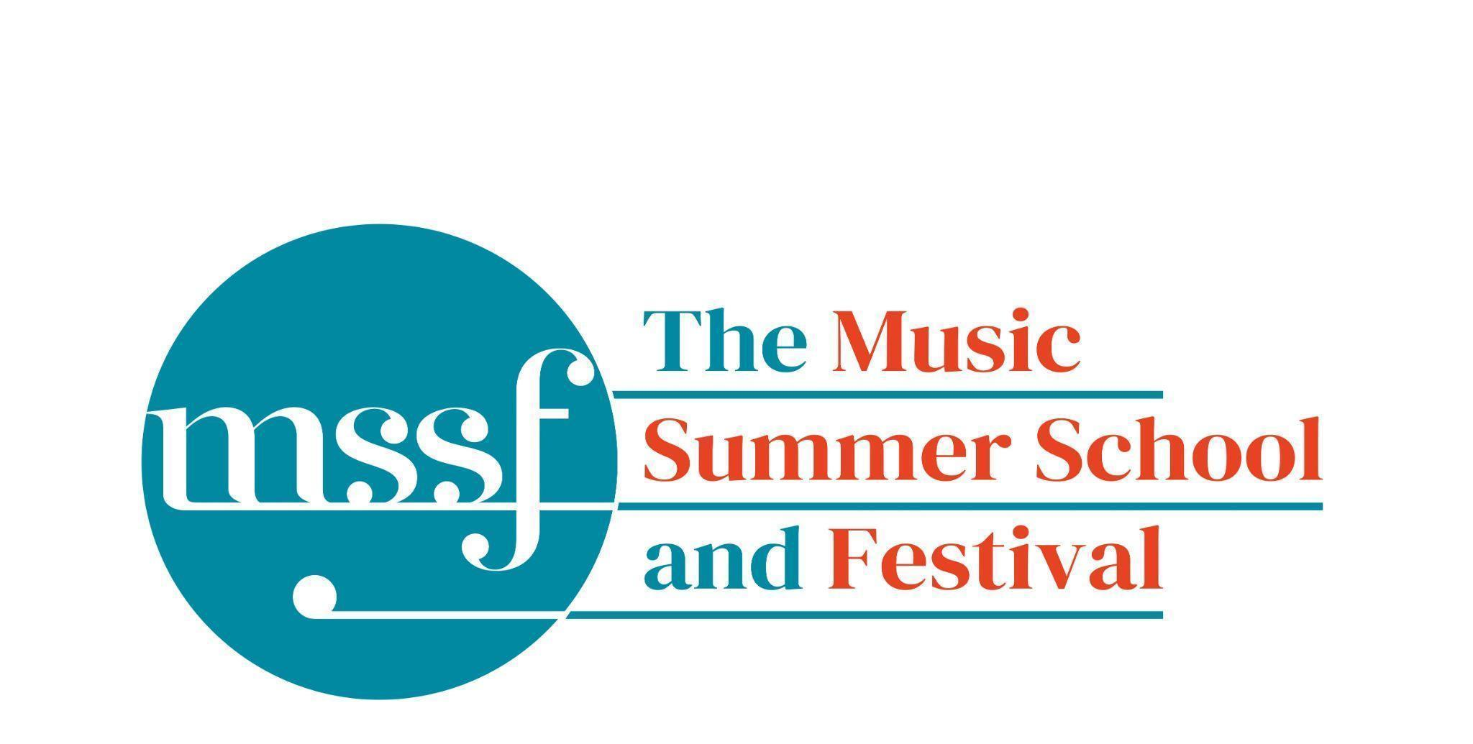

Daily Programme
Tuesday 12th August 2025

Tai-Chi - Moving Meditation  With Doris Schierer | Chapel Lawn | 7.15am to 7.45am - the gentle exercise of Tai-Chi helps to improve balance and co-ordination.

Session 1 (09:00-10:30)
Choir : Mendelssohn - Elijah  directed by David Temple | Chapel | Scores available for hire, or collection if pre-ordered, from the Summer School Office.
Orchestral Workshop  directed by Richard Heason | Various rooms in Big School | Mendelssohn - Elijah  09:00 - 10:00 Sectionals  Flutes and Oboes - Big School 1  Clarinets and Bassoons - Big School 2  Horns - Big School 3  Strings - Big School Hall  10:00 - 10:30 Tutti in Big School Hall
Chamber Music  directed by Rhiannon Evans | Various | Britten Building 3, 9, 10, 18, 20  Dyson Building D105, D107
Brass Ensembles  Directed by Paul Archibald and Roger Argente | New Hall  Reith Building | This is on the 2nd floor. There is a lift at the end of the left corridor (choose floor 3)

Morning Break (10:30 – 11:00)

Session 2 (11:00-12:30)

Chamber Music  directed by Rhiannon Evans & Anna Tilbrook | Various | Britten Building B9,18,20
Chamber Choir - A Sprig of Thyme  directed by Gavin Roberts | Chapel
Song Writing - Songs of the Forest  directed by Anna Anise | Big School 3
Wind Band  directed by Steve Dummer | Big School Hall
Piano  directed by Florian Mitrea | Fishmongers’ Hall  Britten Building
Double Bass  directed by Leon Bosch | B10  Britten Building
Voice  directed by James Platt | Elephant Steps  Dyson Building
Cello  directed by Michal Kaňka | D107  Dyson Building
Viola  directed by Jakub Čepický | D114  Dyson Building
Violin  directed by Leoš Čepický | D105  Dyson Building

Lunch Break (12:30 – 14:00)
Session 3 (14:00-15:30)
Chamber Music  directed by Rhiannon Evans, Anna Tilbrook, Wihan Quartet | Various | Britten Building - B9, B20  Dyson Building - D105, D107
Voice  directed by James Platt | D114  Dyson Building
Voice  directed by Sarah Gabriel | Elephant Steps  Dyson Building
Opera Ensemble  directed by Pippa Dames Longworth, Ian Rutherford & Andrew Smith | Auden Theatre
Percussion  directed by Simon Limbrick | B1  Britten Building
Saxophone  directed by Huw Wiggin | B10  Britten Building
Trombone  directed by Roger Argente | New Hall  Reith Building
Trumpet  directed by Paul Archibald | B17  Britten Building
Horn  directed by Jacqueline Kershaw | B18/19  Britten Building
Clarinet  directed by Catriona Scott | D105  Dyson Building
Oboe  directed by Adrian Wilson | D106  Dyson Building
Flute  directed by Jenny Farley | D116  Dyson Building
Bassoon  directed by Kim Murphy | D117  Dyson Building
String Ensemble  directed by Leon Bosch | Big School Hall
Song Writing - Songs of the Forest  directed by Anna Anise | BS3  Big School
Piano  directed by Florian Mitrea | Fishmongers Hall  Britten Building

Session 4 (16:00-17:00)
Chamber Music  directed by Rhiannon Evans, Anna Tilbrook, | Various | Britten Building - B3, B9, B10, B20  Dyson Building - D105, Fishmongers’ Hall
Opera Ensemble  directed by Pippa Dames Longworth, Ian Rutherford & Andrew Smith | Auden Theatre
Opera Ensemble Orchestra  directed by Steve Dummer | Reith Hall
Jazz Cafe  directed by Sarah Gabriel & Huw Wiggins | Big School Hall

Tuesday 12th August 2025
Concerts and Talks
17:15  CONCERT  Paul Archibald - trumpet  Helen Reid - piano | Fishmongers’ Hall | Bohuslav Martinů – Sonatine  Michael Nyman – Flugel Horn and Piano  Cheryl Frances Hoad – Homages (Book 1)  George Antheil – Sonata
19:30  CONCERT  Ferio Saxophone Quartet  Anna Tilbrook - piano | Auden Theatre | Body Language  Join the Ferio saxophone Quartet for an evening of classical and contemporary music featuring works that showcase the brilliance of renowned composers. The concert opens with Bach’s intricate Fugue in G Minor followed by William Byrd’s elegant Pavane and Gigue. Barbara Thompson’s Saxophone Quartet No. 3 ‘Body Language’ is in the centre of the programme leading into the vibrant melodies of Bernstein’s West Side Story Suite. The quartet are then joined by Anna Tilbrook in an arrangement of Shostakovich’s lively Jazz Suite, arranged by Iain Farrington and Iturralde’s evocative “Memorias”
21:30  CONCERT  Hannah Watson Emmrich - piano | Fishmongers’ Hall | Notes from the Undergrowth  A day and night in a forest ecosystem, told through a thematic programme of piano miniatures. With music foraged from the French baroque through to the present day, the programme follows a path through familiar territory and more overgrown corners of the piano repertoire: the brief, evocative nature of the pieces makes them a perfect introduction to composers who are well worth discovering. The concert will include new commissions by Timothy Salter, Joshua Borin and Maki Gajic Murata, tackling some less musically explored species including slime mould (‘Grex’), fireflies and mushrooms!

Office Opening Hours (Dyson Building, Room D05):
Saturday | 8.30am - 10am | 2pm – 6.30pm
Sunday | 8.30am - 12.45pm | 1.45pm - 5.30pm
Monday - Friday | 9am – 12.45pm | 1.45pm - 5.30pm
Practice Rooms and Studio Booking Times:
All studios and practice rooms are open 8am – 10pm.
Booking sheets for practice rooms are posted at 1.45pm daily on each practice room for the following day. On Sundays the sheets will be posted at 8.30am for that day. Larger spaces are sometimes available for practice and can be booked with the Summer School Office Manager – please enquire in the Summer School Office in the Dyson Building (Room D0.05) for availability. These can be booked from 1.45pm for the following day (and from 8.30am on Sunday for Sunday bookings).
The instrument store room is located next door to the Summer School Office in the Dyson Building, Room D04.
Cafe and Bar Opening Hours: Tigs Café, situated in the Britten Building, is open from 10am to 4pm every day. The Auden Theatre Bar is open from 4pm to 11pm every day (midnight on Fridays).
Available in the Cafe - Wraps, Cakes, Light Meals - Hot and Cold Drinks - Ice Cream
Wine at dinner is available to purchase by the glass (£6) or bottle (£20) during dinner. Unfinished bottles can be labelled and kept in the fridge so that you can finish it off another evening.
Croquet - the croquet set is available to borrow from the Summer School Office (Dyson Building, Room D05) during office hours.
Swimming - The swimming pool, included in your summer school package, is open from 6.30am-8.30am and from 4pm-6pm.
Alexander Technique - Jonathon Heather is available for 1:1 and group sessions of Alexander Technique ( this is included as part of your summer school package), please book direct with Jonathon Heather in Room D118 in the Dyson Building.

