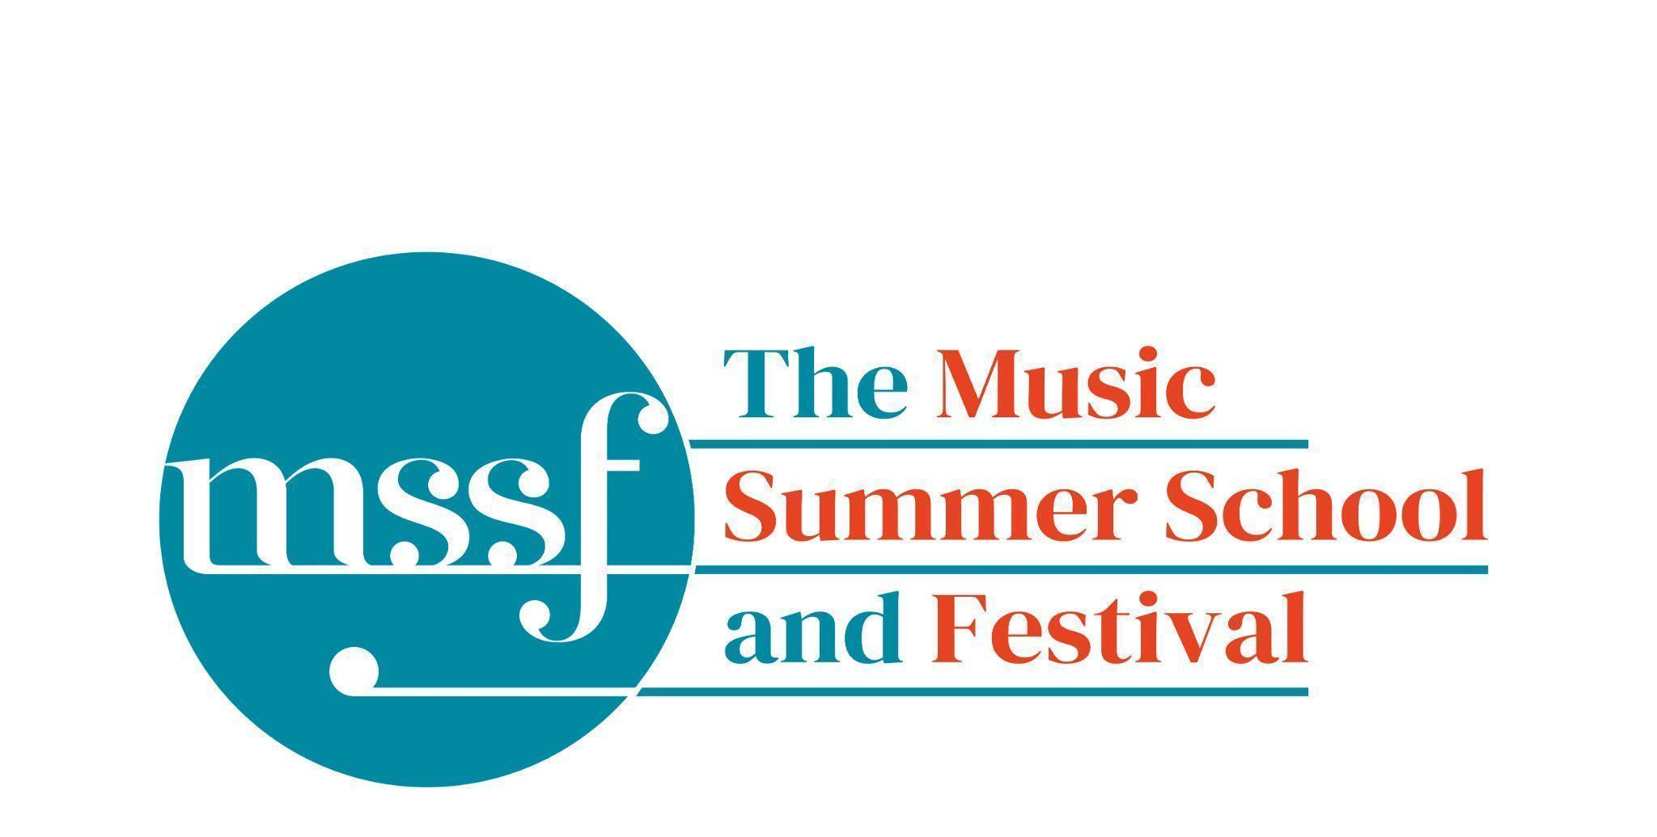
Daily Programme
Thursday 14th August 2025

Tai-Chi - Moving Meditation  With Doris Schierer | Chapel Lawn | 7.15am to 7.45am - the gentle exercise of Tai-Chi helps to improve balance and co-ordination.

Session 1 (09:00-10:30)
Please note change of time: 08:50 - 10:40  Choir: Mendelssohn - Elijah  directed by David Temple | Chapel | We’ve added a little extra time onto either end of the rehearsals because there is so much to get through. Thank you for all your brilliant work and commitment!
Orchestral Workshop  directed by Richard Heason | Big School Hall
Chamber Music  directed by Rhiannon Evans | Various | Britten Building 3, 9, 10, 18, 20  Dyson Building D105, D107
Brass Ensembles  Directed by Paul Archibald and Roger Argente | New Hall  Reith Building | This is on the 2nd floor. There is a lift at the end of the left corridor (choose floor 3)

Morning Break (10:30 – 11:00)

Session 2 (11:00-12:30)

Chamber Music  directed by Rhiannon Evans & Anna Tilbrook | Various | Britten Building B9,18,20
Chamber Choir - A Sprig of Thyme  directed by Gavin Roberts | Chapel | Please note this session will end at 12:00, so that you can get into lunch a little earlier at 12:25 and be ready for the general rehearsal at 13:00.
Song Writing - Songs of the Forest  directed by Anna Anise | Big School 3
Wind Band  directed by Steve Dummer | Theatre in the Woods | Meet at 11am at the back of the Auden Bar, by the benches. We’ll walk to Theatre in the Woods together.
Piano  directed by Florian Mitrea | Fishmongers’ Hall  Britten Building
Double Bass  directed by Leon Bosch | B10  Britten Building
Voice  directed by James Platt | Elephant Steps  Dyson Building
Cello  directed by Michal Kaňka | D107  Dyson Building
Viola  directed by Jakub Čepický | D114  Dyson Building
Violin  directed by Leoš Čepický | D105  Dyson Building

Lunch Break (12:30 – 14:00)

13:00 - 14:00  Chamber Choir and Ensemble  A Sprig of Thyme - general rehearsal  directed by Gavin Roberts | Chapel | Please be in your seats by 12:55 ready to start promptly at 13:00
13:15 - 13:50  LUNCHTIME CONCERT  Julian Davis and Liz Williams - pianos | Fishmongers’ Hall | Beethoven - Piano Concerto No. 3  Ahead of his Bridgewater Hall concert, Julian Davis plays Beethoven Piano Concerto No. 3 with Liz Williams playing the orchestral reduction.

Session 3 (14:00-15:30)
Chamber Music  directed by Rhiannon Evans, Anna Tilbrook, Wihan Quartet | Various | Britten Building - B9, B20  Dyson Building - D105, D107
Voice  directed by James Platt | D114  Dyson Building
Voice  directed by Sarah Gabriel | Elephant Steps  Dyson Building
Opera Ensemble  directed by Pippa Dames Longworth,  Ian Rutherford & Andrew Smith | Auden Theatre
Percussion  directed by Simon Limbrick | B1  Britten Building
Saxophone  directed by Huw Wiggin | B10  Britten Building
Trombone and Trumpet  directed by Roger Argente and Paul Archibald | Chapel | Please note change of venue
Horn  directed by Jacqueline Kershaw | B18/19  Britten Building
Clarinet  directed by Catriona Scott | D105  Dyson Building
Oboe  directed by Adrian Wilson | D106  Dyson Building
Flute  directed by Jenny Farley | D116  Dyson Building
Bassoon  directed by Kim Murphy | D117  Dyson Building
String Ensemble  directed by Leon Bosch | Big School Hall
Song Writing - Songs of the Forest  directed by Anna Anise | BS3  Big School
Piano  directed by Florian Mitrea | Fishmongers Hall  Britten Building

Session 4 (16:00-17:00)
Chamber Music  directed by Rhiannon Evans, Anna Tilbrook, | Various | Britten Building - B3, B9, B10, B20  Dyson Building - D105, Fishmongers’ Hall
Opera Ensemble  directed by Pippa Dames Longworth, Ian Rutherford & Andrew Smith | Auden Theatre
Opera Ensemble Orchestra  directed by Steve Dummer | Reith Hall
Encore Cafe  directed by Sarah Gabriel & Huw Wiggins | Big School Hall
Summer School Choir Extra  directed by Marcus Andrew | Elephant Steps | A bit of a bash through the notes if you’d find it helpful.
Thursday 14th August 2025
Concerts and Talks
17:15  CONCERT  A Sprig of Thyme  Summer School Chamber Choir and Ensemble  directed by Gavin Roberts | Chapel | John Rutter - A Sprig of Thyme  And works by Vaughan Williams played by the Wihan Quartet  Jenny Farley - flute, Adrian Wilson - oboe, Katriona Scott - clarinet, Kim Murphy - bassoon, the Wihan Quartet, Leon Bosch - double bass , Alis Huws - harp
19:00 - 19:30  TALK  The Summer School, now and in the future | Fishmongers’ Hall | An update from Richard Heason on the Summer School, plans for the future and how you can be a part of it.
19:30  PROMENADE CONCERT | Auden Bar,  The Chapel Lawn,  Big School Hall | World premiere of Summer Fanfare by Charles Nelson  Summer School Brass Ensemble directed by Paul Archibald and Roger Argente  Summer School String Ensemble directed by Leon Bosch  Shostakovich Sinfonietta Op. 110 (b) arr. for strings and timpani by Abram Stasevich  Summer School Saxophone Ensemble directed by Huw Wiggins
 |  | Enjoy a drink on Big School Lawn between these two concerts
21:30  CONCERT  Desert Island Songbook  Sarah Gabriel - soprano  Gavin Roberts & Florian Mitrea - piano  Steve Dummer - clarinet | Big School Hall | A long-awaited opportunity for long-term collaborators and friends, Sarah Gabriel, Steve Dummer, Gavin Roberts and Florian Mitrea to perform together – with a relaxed concert of their absolute favourite songs of all time. Having spent much of their musical lives concocting pristine and tasteful programmes on fine themes, their brief for selecting music for this concert is: would they put it on their Desert Island Disc list? Having narrowed things down from an extremely long longlist, join them for their hotly-contested shortlist of rightfully beloved – and also inexplicably unfamiliar – music from the renaissance to the 21st century – by Hildegard von Bingen, Handel, Poulenc, Arlen, Gershwin, Weill, and others.

Minibus Transfers to Sheringham station on Saturday for the 09:43 train
The following people have signed up to the minibus. If you are on this list but shouldn’t be, or you are not on it and would like to be, please contact the Summer School office.
Oakeley residents will be picked up at Oakeley at 08:45 and taken to the main car park to pick up more passengers.
David will take Lawns residents directly from Lawns to the car park for 08:45
Residents for Farfield, Edinburgh, Howsons, Tallis and Woodlands should be at the main car park at 08:45
Tilbrook | Anna |  | Carr | Tom
Robinson | Yvonne |  | Crump | Diana
Arnold | Steve |  | Griffiths | Peter
Nicky | Hayes |  | Jones | Irmtraud
Haynes | Barbara |  | Roberts | Gavin
Donaldson | Julie |  | Rogers | Barnaby
Jackson | Anita |  | Stewart | Marion
Mckenna | Hilde |  | Stewart | Charles
Teng | Josephine |  | Stewart | Marion
Longden | Janet |  | White | Jenny
Gamperle | Claudia |  | Zosel | Barbara
Veal | Andrew

Office Opening Hours (Dyson Building, Room D05):
Saturday | 8.30am - 10am | 2pm – 6.30pm
Sunday | 8.30am - 12.45pm | 1.45pm - 5.30pm
Monday - Friday | 9am – 12.45pm | 1.45pm - 5.30pm
Practice Rooms and Studio Booking Times:
All studios and practice rooms are open 8am – 10pm.
Booking sheets for practice rooms are posted at 1.45pm daily on each practice room for the following day. On Sundays the sheets will be posted at 8.30am for that day. Larger spaces are sometimes available for practice and can be booked with the Summer School Office Manager – please enquire in the Summer School Office in the Dyson Building (Room D0.05) for availability. These can be booked from 1.45pm for the following day (and from 8.30am on Sunday for Sunday bookings).
The instrument store room is located next door to the Summer School Office in the Dyson Building, Room D04.
Cafe and Bar Opening Hours: Tigs Café, situated in the Britten Building, is open from 10am to 4pm every day. The Auden Theatre Bar is open from 4pm to 11pm every day (midnight on Fridays).
Available in the Cafe - Wraps, Cakes, Light Meals - Hot and Cold Drinks - Ice Cream
Wine at dinner is available to purchase by the glass (£6) or bottle (£20) during dinner. Unfinished bottles can be labelled and kept in the fridge so that you can finish it off another evening.
Croquet - the croquet set is available to borrow from the Summer School Office (Dyson Building, Room D05) during office hours.
Swimming - The swimming pool, included in your summer school package, is open from 6.30am-8.30am and from 4pm-6pm.
Alexander Technique - Jonathon Heather is available for 1:1 and group sessions of Alexander Technique ( this is included as part of your summer school package), please book direct with Jonathon Heather in Room D118 in the Dyson Building.

