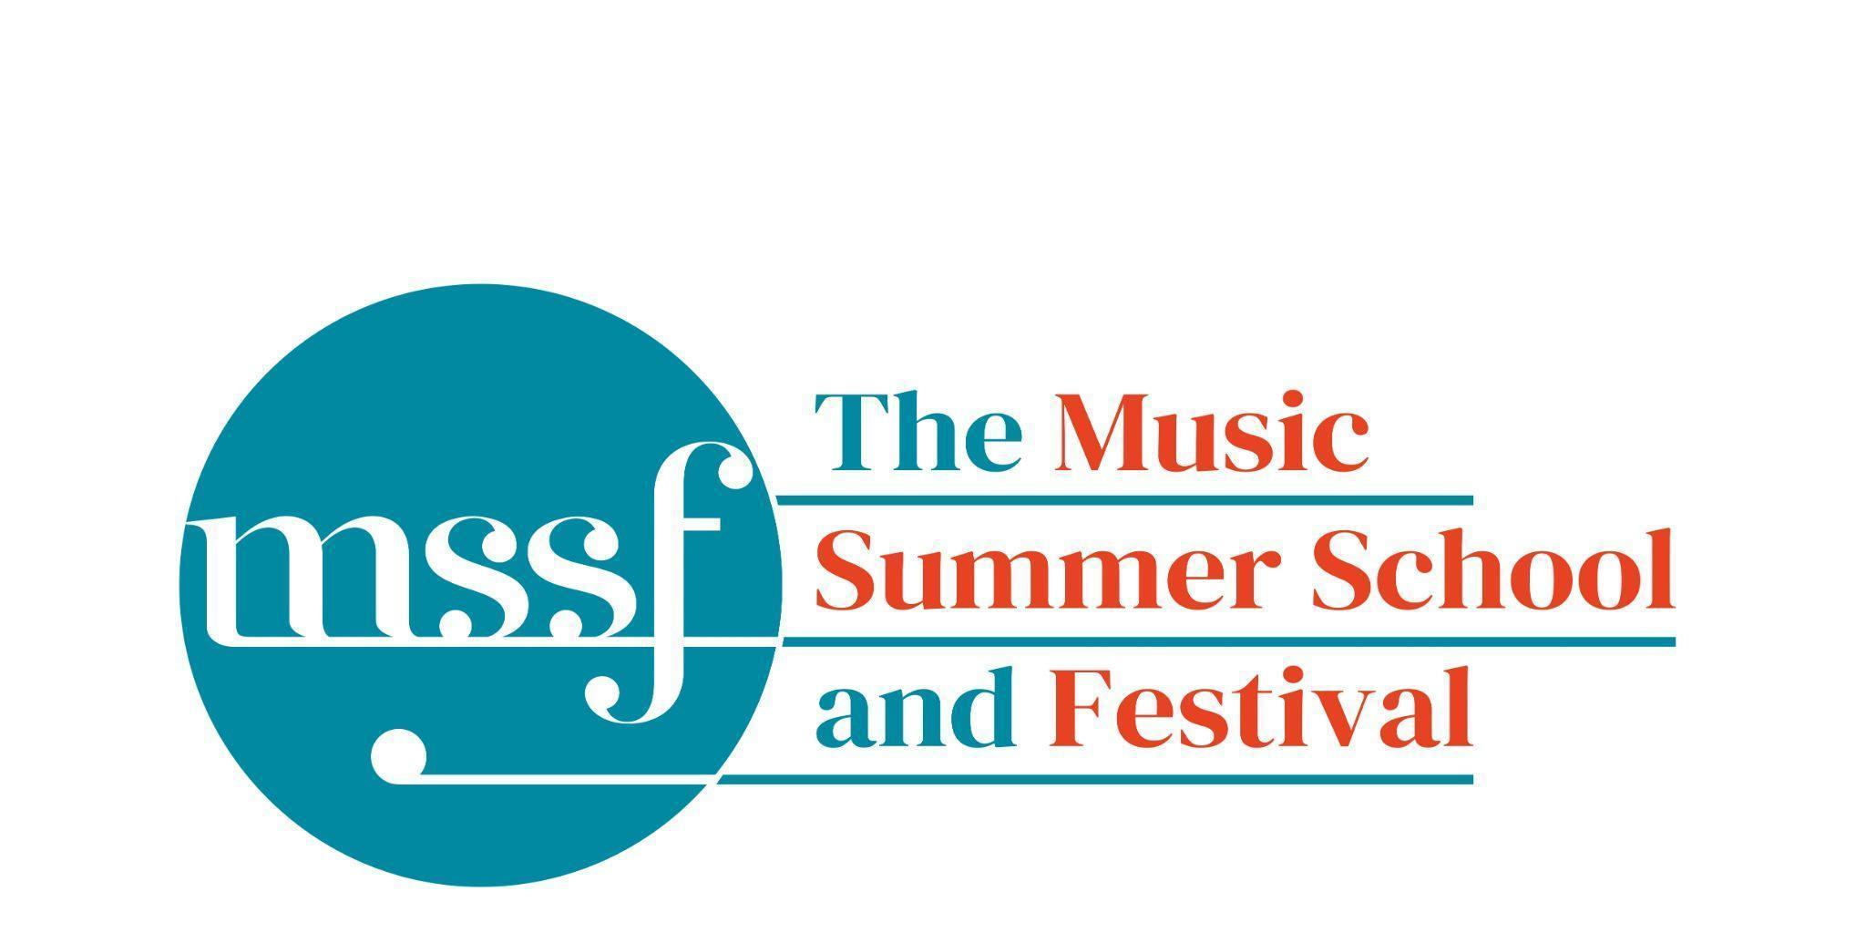

Daily Programme
Monday 11th August 2025

Tai-Chi - Moving Meditation  With Doris Schierer | Chapel Lawn | 7.15am to 7.45am - the gentle exercise of Tai-Chi helps to improve balance and co-ordination.

Session 1 (09:00-10:30)
Choir : Mendelssohn - Elijah  directed by David Temple | Chapel | Scores available for hire, or collection if pre-ordered, from the Summer School Office.
Orchestral Workshop  directed by Richard Heason | Big School Hall | Mendelssohn - Elijah  Please bring a stand if you have one.
Chamber Music  directed by Rhiannon Evans | Various | Britten Building 3, 9, 10, 18, 20  Dyson Building D105, D107
Brass Ensembles  Directed by Paul Archibald and Roger Argente | New Hall  Reith Building | This is on the 2nd floor. There is a lift at the end of the left corridor (choose floor 3)

Morning Break (10:30 – 11:00)
Session 2 (11:00-12:30)

Chamber Music  directed by Rhiannon Evans & Anna Tilbrook | Various | Britten Building B9,18,20
Chamber Choir - A Sprig of Thyme  directed by Gavin Roberts | Chapel | Scores available for hire from the Summer School Office.
Song Writing - Songs of the Forest  directed by Anna Anise | Big School 3
Wind Band  directed by Steve Dummer | Big School Hall
Piano  directed by Florian Mitrea | Fishmongers’ Hall
Double Bass  directed by Leon Bosch | B10  Britten Building
Voice  directed by James Platt | Elephant Steps
Cello  directed by Michal Kaňka | D107  Dyson Building
Viola  directed by Jakub Čepický | D114  Dyson Building
Violin  directed by Leoš Čepický | D105  Dyson Building

Lunch Break (12:30 – 14:00)
Session 3 (14:00-15:30)
Chamber Music  directed by Rhiannon Evans, Anna Tilbrook & Wihan Quartet | Various | Britten Building - B9, B20  Dyson Building - D105, D107
Voice  directed by James Platt | D114  Dyson Building
Voice  directed by Sarah Gabriel | Elephant Steps
Opera Ensemble  directed by Pippa Dames Longworth, Ian Rutherford & Andrew Smith | Auden Theatre
Percussion  directed by Simon Limbrick | B1  Britten Building
Saxophone  directed by Huw Wiggin | B10  Britten Building
Trombone  directed by Roger Argente | New Hall  Reith Building
Trumpet  directed by Paul Archibald | B17  Britten Building
Horn  directed by Jacqueline Kershaw | B18/19  Britten Building
Clarinet  directed by Catriona Scott | D105  Dyson Building
Oboe  directed by Adrian Wilson | D106  Dyson Building
Flute  directed by Jenny Farley | D116  Dyson Building
Bassoon  directed by Kim Murphy | D117  Dyson Building
String Ensemble  directed by Leon Bosch | Big School Hall
Song Writing - Songs of the Forest  directed by Anna Anise | BS3  Big School
Piano  directed by Florian Mitrea | Fishmongers Hall

Session 4 (16:00-17:00)
Chamber Music  directed by Rhiannon Evans, Anna Tilbrook, | Various | Britten Building - B3, B9, B10, B20  Dyson Building - D105, Fishmongers’ Hall
Opera Ensemble  directed by Pippa Dames Longworth, Ian Rutherford & Andrew Smith | Auden Theatre
Opera Ensemble Orchestra  directed by Steve Dummer | Reith Hall
Jazz Cafe  directed by Sarah Gabriel & Huw Wiggins | Big School Hall

Monday 11th August 2025

Concerts and Talks
17:15  GUIDED TOUR  Simon Kinder | Meet at Elephant Steps | Explore the stories of Gresham’s, including its famous alumni Britten, Auden and Berkeley, on this guided tour led by the School’s Director of History
19:30  CONCERT  Wihan Quartet | Chapel | Wolfgang Amadeus Mozart – Quartet no. 23 in F major, K. 590, ‘Prussian’ no. 3  Bedřich Smetana – Quartet no. 2 in D minor  Antonín Dvořák – Quartet no. 12 in F major, op. 96, B. 179, ‘American’
21:30  FIRESIDE CONCERT  Anna Anise | Meet outside the Auden Theatre Bar (by the benches) | “A Solo Fireside Performance of Original songs in Cornish in the Holt woodlands”  Rooted in her Cornish heritage, Anna’s new body of work blends the Cornish language with full-bodied guitar tunings, and her rich, textured vocals which draw listeners into each song’s journey. Anna’s music reflects her connection to the land, capturing the essence of her Cornish roots while offering a fresh, contemporary take on folk.

Office Opening Hours (Dyson Building, Room D05):
Saturday | 8.30am - 10am | 2pm – 6.30pm
Sunday | 8.30am - 12.45pm | 1.45pm - 5.30pm
Monday - Friday | 9am – 12.45pm | 1.45pm - 5.30pm
Practice Rooms and Studio Booking Times:
All studios and practice rooms are open 8am – 10pm.
Booking sheets for practice rooms are posted at 1.45pm daily on each practice room for the following day. On Sundays the sheets will be posted at 8.30am for that day. Larger spaces are sometimes available for practice and can be booked with the Summer School Office Manager – please enquire in the Summer School Office in the Dyson Building (Room D0.05) for availability. These can be booked from 1.45pm for the following day (and from 8.30am on Sunday for Sunday bookings).
The instrument store room is located next door to the Summer School Office in the Dyson Building, Room D04.
Cafe and Bar Opening Hours: Tigs Café, situated in the Britten Building, is open from 10am to 4pm every day. The Auden Theatre Bar is open from 4pm to 11pm every day (midnight on Fridays).
Available in the Cafe - Wraps, Cakes, Light Meals - Hot and Cold Drinks - Ice Cream
Wine at dinner is available to purchase by the glass (£6) or bottle (£20) during dinner. Unfinished bottles can be labelled and kept in the fridge so that you can finish it off another evening.
Croquet - the croquet set is available to borrow from the Summer School Office (Dyson Building, Room D05) during office hours.
Swimming - The swimming pool, included in your summer school package, is open from 6.30am-8.30am and from 4pm-6pm.
Alexander Technique - Jonathon Heather is available for 1:1 and group sessions of Alexander Technique ( this is included as part of your summer school package), please book direct with Jonathon Heather in Room D118 in the Dyson Building.

